

**Year 6 Transitions 2021**

**St Peter’s School**

**St Peter’s Road, Huntingdon, PE29 7DD**

**This booklet covers**

The information in this booklet can also be found on our school website under the [Join Us section.](https://www.stpetershuntingdon.org/join-us/admissions/year-6-transition.php)

PLEASE NOTE: This information is based on normal school routines and processes. These routines and plans are subject to change based on Government advice regarding COVID-19

**Contents:**

Expectations/Learn, Aspire, Exceed

The behaviour policy

Uniform/equipment

Attendance

School Day

Curriculum

SEND/Medical needs

MyChildAtSchool/Go4schools

Safeguarding and E-safety

Homework/teams

The library

Food at St Peter’s

Finances

Extra-curricular clubs

Personalised Provision/SEND

Travelling to school

Transition day information

First Day arrangements

Contact information

Members of the Pastoral team and the SEND department can be contacted via email for personalised transition support. Contact details below:

Mrs Knibbs: SENDCO

[Jknibbs@stpetershuntingdon.org](mailto:Jknibbs@stpetershuntingdon.org)

Mrs Chapman: Head of Year 7

[achapman@stpetershuntingdon.org](mailto:achapman@stpetershuntingdon.org)

Miss Camargo: Student Support Manager for Year 7 [ccamargo@stpetershuntingdon.org](mailto:ccamargo@stpetershuntingdon.org)

**Expectations (LEARN, ASPIRE, EXCEED)**

At St Peter’s school it is paramount that students are successful during their school life. Students will be encouraged to embrace the school’s motto; Learn, Aspire & Exceed. This school ethos is embedded into school life, from tutor time to lessons in and out of the classroom. Students in Year 7 will also experience a LAE (Learn, Aspire and Exceed) lesson on their timetable which will be linked to this ethos, where students will experience new ways of learning and additional experiences out of the ordinary.

**The behaviour policy**

We have very high levels of expectation when it comes to behaviour in and around school. Recognition will take place for good behaviour and sanctioned for poor behaviour.

All behaviour is logged electronically on a system called E-Behave.

Positive points range from a +1 to a +5.

Positives can be given for a variety of reasons, from giving a good answer in a lesson to representing the school in the community. There are many ways that students can be recognised for their positive points. Recognition ranges from verbal praise to a meeting with Mr Bennet and a range of prizes in between. We also organise regular recognition events within departments of the school to celebrate the work that students have accomplished.

Negative points range from -1 to -5

Negatives would be given for instances of poor behaviour. At St Peter’s we have a system that encourages students to make the correct choice and prevent the sanction from escalating. We will also encourage restorative conversations with staff where necessary.

Sanctions range from a warning to an afterschool detention or isolation.

Afterschool behaviour conversations take place with staff afterschool from 3:05 to 3:35pm (however these range in length, see chart), parents/carers will receive a text message to let them know that their son/daughter has been asked to attend a conversation.

Failure to attend the conversation, to speak with respect to the member of staff will result in a detention which run from 3:05pm to 4:05pm. Parents/Carers will receive text message notification.

If a sanction gets to the level of isolation, parents will be expected to come in for a meeting to discuss the behaviour. Isolation involves a day spent in silence, with a different break and lunch time, completing work. Isolation takes place from 8:30am until 4:05pm.

It is of course our hope that students do not reach this level of poor behaviour.

**Behaviour policy continued…**

**School Expectations**

* To be able to LEARN effectively, always display appropriate and on task behaviour.
* ASPIRE to have your attendance at over 96% and be punctual to school and lessons.
* In order to LEARN, ASPIRE and EXCEED, always follow instructions.
* To be able to LEARN effectively, be fully equipped for lessons and in full uniform.
* In order to LEARN, ASPIRE and EXCEED complete all work to the best of your ability.

**Positive and Negative Behaviours**

Behaviours recorded using e-Behave system.

|  |  |  |
| --- | --- | --- |
| **Level** | **Negative** | **Positive** |
| 1 | Not meeting the standard (reminder) | Meeting the Standard. In lesson recognition. |
| 2 | Afterschool Behaviour conversation (set by class teacher, work/behaviour) | Teacher recognition.  Contact Home. |
| 3 | 1 hour afterschool (extreme poor behaviour/ fail level 2) | Department recognition.  Contact Home. Postcard. |
| 4 | Isolation | Year Team / Senior Leader recognition. |
| 5 | Exclusion | Headteacher recognition |

**Uniform**

**Standards of uniform at St Peter’s School**

Please find some information that we hope will be useful regarding the standards of uniform we expect at St Peter’s School. All uniform requirements are to be followed.

The school understands that the outlay for uniform is considerable and we feel it is important to avoid any confusion as to what is acceptable. Please use the table below to avoid any possible confusion before purchasing uniform items.

It is an important element of the philosophy of the school that students identify themselves with St Peter's and its community. School uniform is, therefore, **compulsory.** The correct uniform should be worn at **all** times to avoid time being wasted in enforcing regulations. If parents find that they have any temporary problems meeting the requirements they should contact, in the first instance, the Student Team for advice. Details of the uniform are summarised below:

ALL STUDENTS MUST HAVE **BOTH** A SWEATSHIRT AND POLO SHIRT

|  |
| --- |
| Navy blue school V-necked jumper with embroidered school logo.  Blue polo shirt embroidered with school logo |

|  |  |
| --- | --- |
| **BOYS**  Smart black trousers  Plain, dark black socks  Black shoes | **GIRLS**  Blue pleated tartan skirt , smart black trousers  Black socks (no brightly coloured fashion socks)  Black shoes |

**PE EQUIPMENT**

|  |
| --- |
| **BOYS AND GIRLS** |
| Royal blue shirt embroidered with the school logo  Royal blue shorts  Royal blue socks with turn down |
| Optional– long sleeve shirt embroidered with the school logo |
| Gym shoes or trainers  Suggested items; Shin pads and gum shields |

These items can only be purchased from The Uniform Specialists

For more information on ordering uniform please see the download documents on the left hand side of the [transition section](https://www.stpetershuntingdon.org/join-us/admissions/year-6-transition.php) of our website.

|  |  |
| --- | --- |
| **UNIFORM** | **INFORMATION AND EXPECTATIONS** |
| Light blue Polo shirt, with St Peter’s School logo | No other visible top of any sort should be seen under polo shirt. |
| V neck jumper with St Peter’s School logo | No other top should be visible under the v-neck jumper.  Cannot be substituted with any other top, jumper or cardigan. The jumper is optional in summer. |
| Outdoor coat. Must be one plain, dark colour. | No hoodies, sports tops, track suit tops, branded jackets or coats, or branded sweatshirts. **If worn they will be confiscated.** |
| Trousers | Black, full length tailored trousers only. No leggings, skinny trousers or culottes. No denim of any type. No studs or embroidery on pockets. Girls **will not** be allowed to wear tight fashion trouser or leggings. |
| Skirt | Blue tartan school skirt must be knee length. |
| Belts | Must not be seen, if worn must be plain black and not a fashion belt, eg.with a large buckle. |
| Hats / Scarves | To be worn outside school buildings only, not allowed in lessons. Suitable for winter weather and not as a fashion accessory. |
| Make up | Years 7 and 8 – No make up at all.  Years 9, 10 and 11 – SUBTLE make up only.  Nail varnish must only be clear |
| Jewellery | No bracelets, bangles, rings or necklaces. ONE small stud allowed in each ear. **No facial piercings of any sort,** lip, face, eyebrow or tongue.  **This is strictly enforced any student found with a facial piercing will immediately be withdrawn from lessons and parents contacted.** |
| Black shoes | Shoes must be completely black and sensible; not a health and safety risk. |
| Hair | No extreme haircuts, no patterns shaved into hair, one natural colour only. |
| School Bags | An appropriate school bag eg rucksack or holdall to transport books and equipment including pens and pencils. No fashion bags, dolly bags, clutch bags or small handbags. |

Our school uniform is to be purchased from The Uniform Specialists. See link below:

[www.theschooluniformspecialists.com](http://www.theschooluniformspecialists.com)

If you are a first-time user, you will be asked to enter the School ID: STP541 and then enter your email address and set a password.

*Students are expected to wear their PE kit on PE days

**Equipment**

In order for students to maximise their potential, it is important that they are fully prepared for every lesson. Below is a list of equipment needed.

**Everyday equipment**

* Pens (blue, black and a green pen for marking)
* Pencils
* Ruler
* Rubber

Some subjects may require additional equipment for lessons. Some equipment will be available to purchase through Parentpay.

**Subject Specific equipment**

* Scientific calculator
* Compass
* Protractor

**Art**

Art books can be ordered through the Finance department. You will receive a letter about Art supplies before September which you can also find the letter on the website under the heading [transitions.](https://www.stpetershuntingdon.org/join-us/admissions/year-6-transition.php)

**Attendance**

The school’s minimum attendance target is 96%.

Parents of any student with attendance lower than this will be contacted.

We will recognise students with 100% attendance.

There is a local and national link between attendance and GCSE performance.

Last year at St Peter’s, students with **100%** attendanceachieved, on average, a **4 in every subject.**

Students with **90%** attendance achieved, on average, a **3 in every subject.**

Students with **80%** attendance were, on average, **below 3 in every subject**.

Students are happier and more confident when they are in school more often.

Students with lower attendance are more anxious about lessons and find following the flow of lessons more difficult.

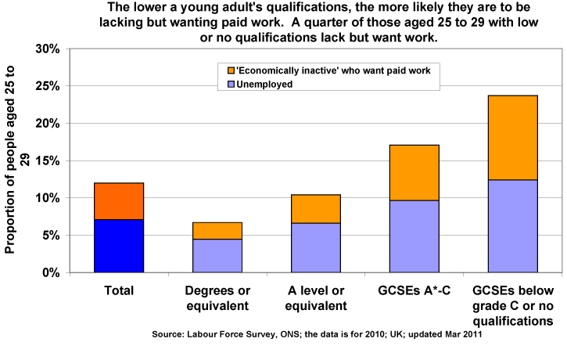

**GCSE 4 - 9**

**GCSE’s 9-4**

**GCSE below level 4 or no qualifications**

**Absence from school**

Please call to inform school if your child is not going to attend school on any day. The number to call is 01480 846770 – if out of hours, please leave a message stating the students name and the reason they will not be in.

If we do not have a reason for a student’s absence, a member of staff will call to ask why.

**Lates**

If a student is late they must sign in as soon as they arrive. They sign in at student services (in the small hall). Once signed in, students must go to the lesson on their timetable immediately. Unless there is a valid reason for being late, students will be issued with a detention.

**Leaving school during the day**

Where possible appointments should be made outside of school hours, however if a student needs to leave school during the day (e.g. doctors appointment) they will need a signed letter from home explaining the reason. Students will then be given a ‘permission to leave school’ slip. They should show this when they sign out at student services.

**Contact details of the attendance officer**

Tracy Williams

01480 459581 (extension 819)

[twilliams@stpetershuntingdon.org](mailto:twilliams@stpetershuntingdon.org)

**The School Day**

The school day runs from 8:30am to 3:05pm and consists of five one-hour lessons, a 30 minute break and a 30 minute lunchtime.

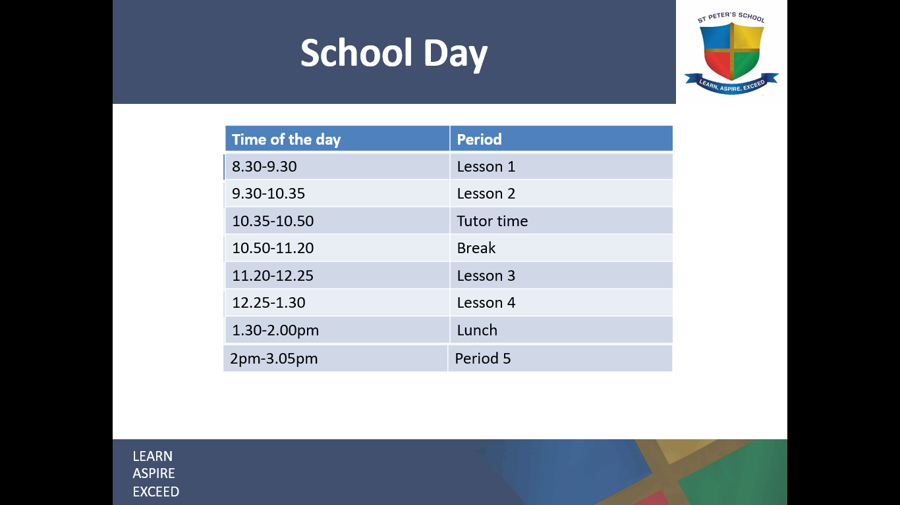

**Tutor time**

Each Year group has 8 tutor groups – each group contains a mix of Year 7 students.

Tutor time takes place every morning, students are registered, important information is given and letters are handed out.

Students will have the same tutor and be with the same students every morning before break time. Students will spend the time completing activities and taking part in events.

**The curriculum**

Students will experience a variety of subjects within the curriculum. Core subjects

(English, Maths, Science) will see students 3-4 times a week. Students will experience

the following lessons;

* English
* Maths
* Science
* Humanities; Geography, History, RE
* Arts; Drama, Music, Art
* French
* ICT
* Design Technology
* PDLS
* LAE; Learn, Aspire & Exceed
* Physical Education

**Medical needs**

Classroom teachers are not able to keep hold of or distribute any medicine.

If your child has any medical needs, you need to contact student services who will be able to assist you in all matters related to medicine. Any prescribed medication will need to be given to student services.

**SEND**

A particular focus is placed on students with special education needs and this is overseen by our dedicated SEND co-ordinator Mrs Knibbs. Students joining us with SEND will have already been in communication with Mrs Knibbs to discuss support and strategies for September. This may range from interventions to nurture classes or a space in The Cabin.

If you have any concerns about your child with regards to SEND, please contact Mrs Knibbs or Mrs Sawyer

[jknibbs@stpetershuntingdon.org](mailto:jknibbs@stpetershuntingdon.org) or nsawyer@stpetershuntingdon.org

01480 459581 (EXT: 724)

*Further SEND information later in this booklet

**Monitoring your child at St Peter’s**

At St Peter’s we have two systems that we use to track and monitor students. Login details for both will be sent in September.

**Go4Schools**

Go4Schools is an online system that is used to track student’s academic achievements.

Parents can log on and find the most up to date information about grades from each subject and a breakdown of each area within that subject.

Go4Schools shows 3 grades: Target grades, Current grade, Projected grades.

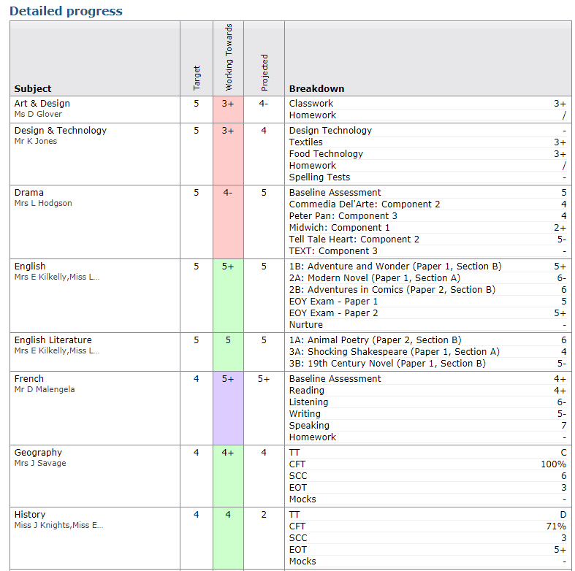

[Grab your reader’s attention with a great quote from the document or use this space to emphasize a key point. To place this text box anywhere on the page, just drag it.]

[Grab your reader’s attention with a great quote from the document or use this space to emphasize a key point. To place this text box anywhere on the page, just drag it.]

[Grab your reader’s attention with a great quote from the document or use this space to emphasize a key point. To place this text box anywhere on the page, just drag it.]

[Grab your reader’s attention with a great quote from the document or use this space to emphasize a key point. To place this text box anywhere on the page, just drag it.]

[Grab your reader’s attention with a great quote from the document or use this space to emphasize a key point. To place this text box anywhere on the page, just drag it.]

[Grab your reader’s attention with a great quote from the document or use this space to emphasize a key point. To place this text box anywhere on the page, just drag it.]

[Grab your reader’s attention with a great quote from the document or use this space to emphasize a key point. To place this text box anywhere on the page, just drag it.]

[Grab your reader’s attention with a great quote from the document or use this space to emphasize a key point. To place this text box anywhere on the page, just drag it.]

**MCAS – My Child at School**

MCAS is an online system that parents can log into and see up to date information on attendance and behaviour. It gives a lesson by lesson attendance break down and a full breakdown of all E-Behaves given.

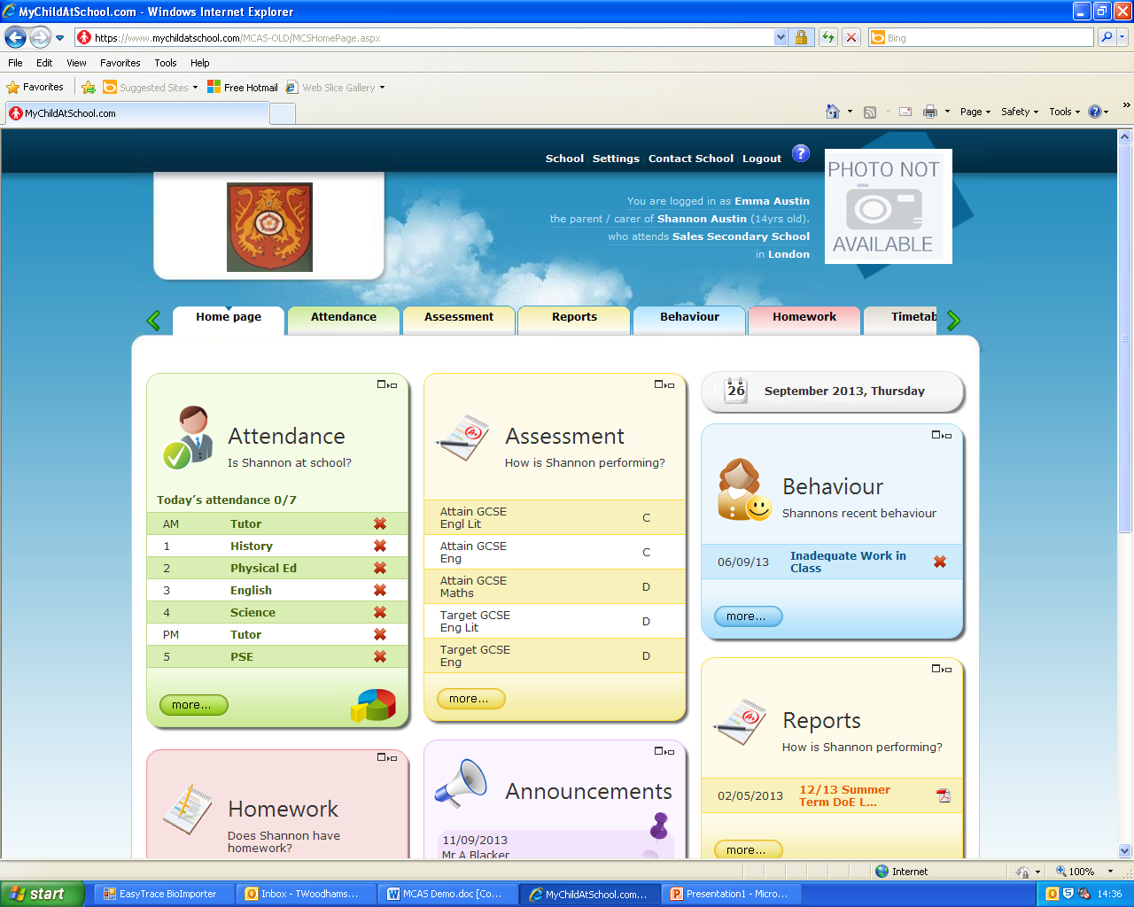

**Safeguarding**

The Safeguarding team is based in the link corridor and students are able to visit them to share any concerns that they may have. In order to ensure the safety of our students, the team is made up of a range of different people however the following members of staff have key responsibilities for safeguarding and are trained as Designated Safeguarding Leads:

**Mrs Anni Matthew** – Assistant Head Teacher/Designated Safeguarding Lead  [amatthew@stpetershuntingdon.org](mailto:amatthew@stpetershuntingdon.org)

**Mrs Jose Cox** – Lead for Safeguarding and Child Protection Prevent Lead  [jcox@stpetershuntingdon.org](mailto:jcox@stpeters.cambs.sch.uk)

**Mrs Nicky O’Connell**– Safeguarding Officer/ Support for Looked After Children [noconnell@stpetershuntingdon.org](mailto:noconnell@stpetershuntingdon.org)

We work closely with all pastoral teams and outside agencies to ensure the very best for our students. Parents can find other information about safeguarding at St Peter’s on the website, along with other links that they may find useful.

**E-Safety**

Internet safety is incredibly important both in and out of school. Whilst students are in school, they are not permitted to use their mobile phones, and any internet access should be on the St Peter’s school computers. The pastoral team monitor internet usage and will contact you if there are any concerns regarding student’s search histories. We also encourage parents/ carers to contact the pastoral team if you have any concerns as a parent.

There is a support and advice to parents/carers on supporting your child with their online safety on our [website.](https://www.stpetershuntingdon.org/parents-carers-students/e-safety.php)

**Homework/Teams**

It is important to remember that each department is different and some departments will set homework every week, whereas other departments will wait until they have completed a unit of work and then set a piece of homework to complete the unit.

Students should use their homework diary to record homework.

Students will be given a sufficient amount of time to complete and hand in the work.

If students are unable to complete the homework at home they can use the library; which is not only an area to go and work but also students have access to computers/books to aid research topics. The library is open daily until 4pm Monday-Thursday and until 3.30pm on a Friday.

Teams is a new online platform we are using at St Peter’s to revolutionise homework/classwork. This can be used on any device for students to electronically store their work but it also allows teachers to send documents; these can be marked by staff and edited by students. Students will be taught how to use this.

**The Library**

We are very lucky to have such a fantastic resource in our school library. A place that is not only home to over 12,000 books but also a number of computers, magazines/newspapers to read and a very knowledgeable, friendly and helpful librarian.

Students are able to go to the library at break, lunchtime and afterschool, and students can take books home using their school library card.

*The library is open until 16:05 Monday-Thursday and until 15.30 on Fridays.

**Food at St Peter’s**

Students have a choice of whether they want to bring a packed lunch to school or have school dinners from the canteen.

* Break time is 30 minutes.
* Lunch time is 30 minutes.

In order to prevent the school site potentially being full of litter, food is only to be eaten in or around the canteen (even packed lunch). There is a covered area outside the canteen to sit and eat. Students will be expected to carry their packed lunch with them during the school day.

**School dinners**

The canteen serves snacks and drinks at break time.

At lunch time the canteen has one side that serves hot meals and one that serves cold food (sandwiches). There are 2 different queues depending on which one the student wants.

Meal deal - £2.35 – Main, dessert, drink

**Paying for food**

The canteen uses a cashless system to save time when buying food. Students will use their biometrics to load money onto the system in the small hall (near student services) which they can then use in the canteen.

Money can also be loaded onto their account via parent pay – which is found on the school website.

**Finance**

All monies at school are managed by the Finance department, from trips to school dinners. Please use the online ‘Parent Pay’ system to pay for different items/events.

**Extra-Curricular clubs**

The school day does not necessarily end at 3:05pm; there are many opportunities for students to be involved in extra-curricular throughout the year.

**Personalised curriculum**

At St Peter’s it is important that all students reach their potential. St Peter’s is a mainstream provider but is proud of the additional support mechanisms we offer to allow all students to achieve.

**Stretch and Challenge:** Stretch and Challenge has been running for several years and has become of our yearly programme. Stretch and Challenge comprises of a series of lessons that are offered to HPA students (High Prior Attainers) in order to support extended learning opportunities. This can be Science experiments that are ordinarily completed with older students for example. Previous students have enjoyed this personalised learning opportunity.

**Student Voice:** We perform regular student voice activities with students to identify what students are enjoying and finding challenging during their first year at secondary school. This allows the pastoral team to speak to teachers and support individual needs.

**Junior Student Leaders:** We will offer a small group of Year 7 students the chance to work with the Senior student leaders to provide support and mentoring to Year 6 and Year 5 students in our partner primary schools.

**Meetings and PSPs (Pastoral Support Plans):** We appreciate that all students have different needs and in order to support students to be successful at St Peter’s we will invite families into school for meetings to discuss behaviour, attitude to learning or to discuss any concerns/worries a student or their parents/carers might be experiencing. We passionately believe that strong pastoral support with enable students to enjoy and embrace school life.

**Trips and clubs:** During Year 7 we will offer different opportunities for students to attend cultural experiences, from Art galleries to theatre trips. Year 7 will also be offered different opportunities out of school to hone individual talents such as sporting clubs and music school.

**STRIVE:** We understand that mainstream education is not suitable for all students. STRIVE is our onsite alternative education programme run by specialists in this field. Students experience learning outside the classroom opportunities as well as bespoke and small group lessons in order to encourage and instil learning in other ways.

**SEND:**

The SEND department has been growing and changing over the last 6 years to meet the needs of the students that come to St. Peter’s. There is currently a team of 15 dedicated staff that make up the SEND department. We offer a wide range of support from advising teachers of students’ needs and how to best support them in class; Pupil Passports; mentors; adapted resources such as coloured exercise books and paper; technical support such as laptops and software, a range of tutor time interventions depending of the need such as numeracy, phonics, reading comprehension, mentoring and social skills. We also have an area dedicated to the SEND department that certain students can utilise during breaks and lunchtimes to socialise, with adult supervision.

Students with very high needs, that would be very difficult to meet in most mainstream lessons, may be offered support through our Nurture provision. Nurture classes have small group sizes and are taught by a SEND teacher with TA support for up to 17 lessons a week. The emphasis is on numeracy, literacy and social skills. Additionally, we offer an enriched curriculum which facilitates some learning outside of the classroom with the aim of developing confidence and resilience. Students that are in Nurture, are constantly monitored to ensure that they are ready to move into more mainstream lessons as soon as they are ready. Students with EHCPs that fit the criteria of the Nurture provision, have priority to this support. Students without EHCPs, may also benefit from Nurture support and these students are identified

through consultation with primary SENDCo’s and parents.

Support staff tend to work within the Nurture department in KS3 and within mainstream lessons in KS4. We have some PA’s that support students with physical and sensory impairments in all key stages to ensure that they can access their education.

Students with EHCPs (E) and students receiving SEND support over and above classroom adaptations (K)are on our official SEND register. Students with a diagnosis or with identified SEND whose needs are met through high quality classroom teaching are not on the SEND register but are still monitored. Students may move on and off the SEND register during their time at St. Peter’s but this does not alter our care of them. Every student on the SEND register has a named adult (mentor) who will meet with the students and contact parents during the year. The regularity of this contact differs for each student and is tailored to their needs. This gives both parents and students someone they can contact initially when wanting to discuss their SEND.

As well as interventions, we have several assessments we can use that enable us to determine whether a student has SEND and if so what support we or the local authority can offer. Such assessments include a dyslexia screener that will determine the probability of dyslexia and the areas of weakness, a numeracy assessment that can show us if there are gaps in basic numeracy and give a numeracy age, reading and spelling age tests and phonic skills assessments.

We also have a specialist autism provision called The Cabin. There is a separate application process for this provision which requires students to already have an autism diagnosis and an EHCP. Because of this provision, all SEND staff are adept in assessing areas of need relating to social communication difficulties and address those needs through targeted provision.

**Travelling to school**

At St Peter’s School we promote sustainable travel and encourage students to walk or cycle to school.

There are pavements with cycling paths for use by students on Sallowbush Road and Ambury Road. There are gates for students to use on Ambury Road and the road by One Leisure.

St Peter’s School map showing gates to be used when arriving at/leaving school. 

Please see below for safety advice for students and parents planning journeys to school from <https://www.think.gov.uk/>

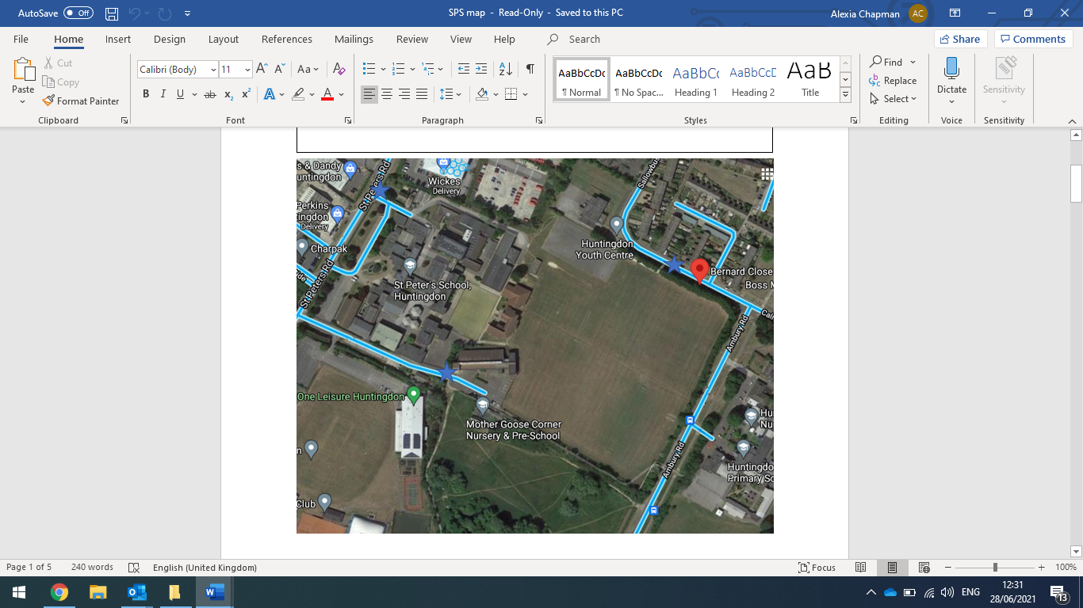

**By Bus**

Some students will be eligible to transportation. This must be applied for through the Cambridgeshire County Council. Please see the link below:

[**https://cambridgeshire-self.achieveservice.com/service/Pre_16_Home_to_School_Transport**](https://cambridgeshire-self.achieveservice.com/service/Pre_16_Home_to_School_Transport)

**Advice for cyclists**

Students are allowed to bike to school and we have a bike shed on school site (North Road- near Wickes) Students will need to have a bike lock to safely secure their bike. See road safety support:

* Ride decisively and keep clear of the kerb.
* Look and signal to show drivers what you plan to do, make eye contact where possible.
* Avoid riding up the inside of vehicles, as you might not be seen. If a vehicle is indicating to the left hang back at the junction to reduce the risk of a collision.
* Always use lights after dark or when visibility is poor. Wear high-visibility and reflective clothing and accessories at all times
* Wear a correctly fitted cycle helmet that is securely fastened and conforms to current regulations.
* Your local council can help you plan your journey by providing maps showing dedicated paths and routes.
* Where possible, try to maintain [**social distancing**](https://www.gov.uk/government/publications/staying-alert-and-safe-social-distancing/staying-alert-and-safe-social-distancing) when you cycle, for example when waiting at crossings and traffic lights.
* Where using bikes (private, docked or dockless) wash your hands for at least 20 seconds or sanitise your hands before and after cycling.

[www.think.gov.uk/cycle-safety/](http://www.think.gov.uk/cycle-safety/)

[**Highway Code rules for cyclists**](https://www.gov.uk/rules-for-cyclists-59-to-82)

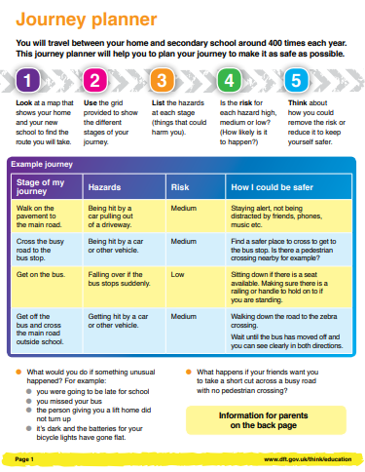

**The first day 6th September 2021 *This is subject to change given governmental guidelines**

* Students will meet in the Year 7 area (near the swimming pool) at 8:30
* FIRST DAY ONLY STUDENTS MAY USE RECEPTION ENTRANCE IF NECESSARY
* Please note that parents / carers will not be able to accompany students into school
* First day assembly taken by Mr Bennet
* Meet tutors & the rest of horizontal tutor group
* Timetables received
* School Tour
* Period 3, 4 and 5 are normal timetabled lessons
* Lunch time for year 7 will start at 13:20 for the first week.
* Please confirm arrangements to pick your student up. The end of the school day 3:05 pm.

**Useful Contacts**

**St Peter’s school**

01480 459581

[office@stpeters.cambs.sch.uk](mailto:office@stpeters.cambs.sch.uk)

Our office staff are able to pass on messages & emails to any member of staff or put you through to extensions.

**Mrs Chapman**

Head of year

[achapman@stpetershuntingdon.org](mailto:achapman@stpetershuntingdon.org)

Direct line

01480 459581 (EXT: 740)

**Miss Camargo**

Student support manger

Direct line

01480 459581 (EXT: 740)

[ccamargo@stpetershuntingdon.org](mailto:ccamargo@stpetershuntingdon.org)

**Mrs O’Connell**

Transitions co-ordinator/Safeguarding Officer/Designated LAC support worker

Direct line

01480 459581 (EXT: 792)

[noconnell@stpetershuntingdon.org](mailto:noconnell@stpetershuntingdon.org)

**Absence line**

01480 846770

Messages should be left before 8.30 am

**Finance office.**

Please call main school number and ask for Finance office.

01480 459581

**11**